Student performance vs teacher salary

Analysis of 4th Grade Standardized Math Testing Compared to Average Teacher Salary by State

ETL Group Project

# Project Proposal

For our project, we propose that we examine student academic performance in the K-12 public education system and its correlation with teacher salaries. Our data sets include a .csv file included in a Kaggle dataset called Student Performance in

# Potential Insights

* What correlations can we find between teacher salary and student test performance?
* How do the factors that affect teacher salary, such as area, average income in state, etc. affect the findings? Do they also affect student performance?

# Extract Data Sources

* Average Teacher Salary by State 2017 **(CSV)**
  + <https://nces.ed.gov/programs/digest/d17/tables/dt17_211.60.asp>
* Academic Success in Mathematics for 4th graders **(CSV)**
  + <https://www.nationsreportcard.gov/profiles/stateprofile?chort=3&sub=MAT&sj=AL&sfj=NP&st=MN&year=2013R3>

# Transform Datasets

* Cleaning
  + Rename Academic Dataset fields:
    - “Jurisdiction” to “State”
    - “AB” to “At or above Basic”
    - “AP” to “At or above Proficient”
  + Rename Salary Dataset fields:
    - “2016-17” to “2016-17 Salary”
* Filtering
  + Salary Dataset
    - Only keep “State” and “2016-17”
  + Academic Dataset
    - Only keep “State”, “At or above Basic”, and “At or above Proficient”
* Joining
  + We will join the two datasets on the “State” field

# Load Datasets

* Using relational database, Postgres, to join the Teacher Salary data and Student Math Performance data.

# Final Table Names

* Salary Dataset SQL table name: **“salary”**
* Academic Dataset SQL table name: **“performance”**
* Academic Performance vs Avg Teacher Salary: **“salary_vs_performance”**

# Results and Analysis

**Hypothesis:**

* Teacher Salary has a positive correlation with “At or Above Basic” test results.
* Teacher Salary has a positive correlation with “At or Above Proficient” test results.

**Results 1: At or Above Basic Performance vs Average Teacher Salary**

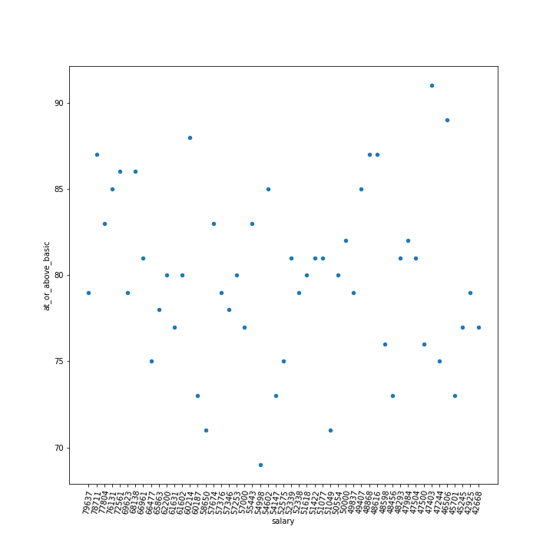There is no clear indication, based on our analysis, that teacher salary has any impact on student performance. Further analysis would need to be done to find better correlated factors to student performance. This would also include revisiting the datasets used.

*Fig1*

**Results 2: At or Above Proficient vs Average Teacher Salary**

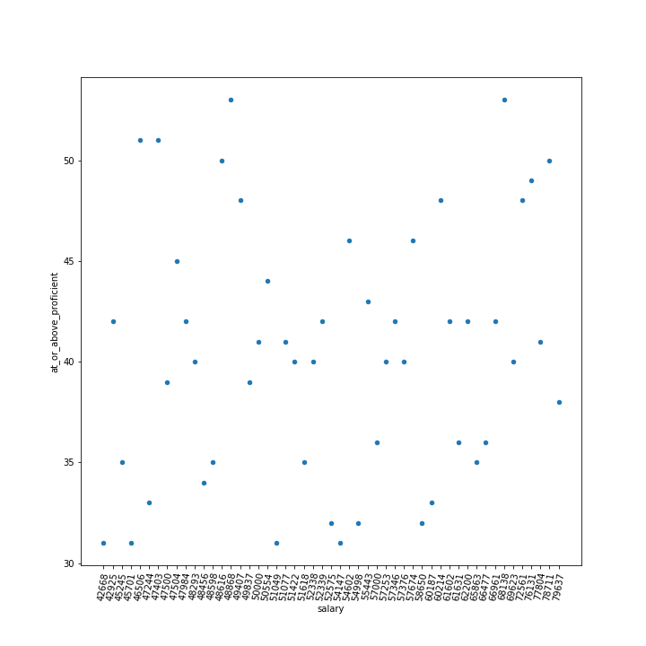Again, we do not see any strong correlation with teacher salary and further analysis would need to be done.

*Fig2*

# Post Mortem

Finding datasets to answer our project proposal proved to be challenging. To keep the scope manageable, we chose to look only at 4th grade students and only the Math performance. Given more time we would have chosen a dataset that included all grades and all standardized subjects.

Considerations for further analysis include:

* Adjusted wage based on cost-of-living
* Impact of performance-based pay
* Average household income vs student performance
* Single-parent homes and dual-parent homes vs student performance